Green Transition in IT
Level: E–D/C (GF2 Data Technician)

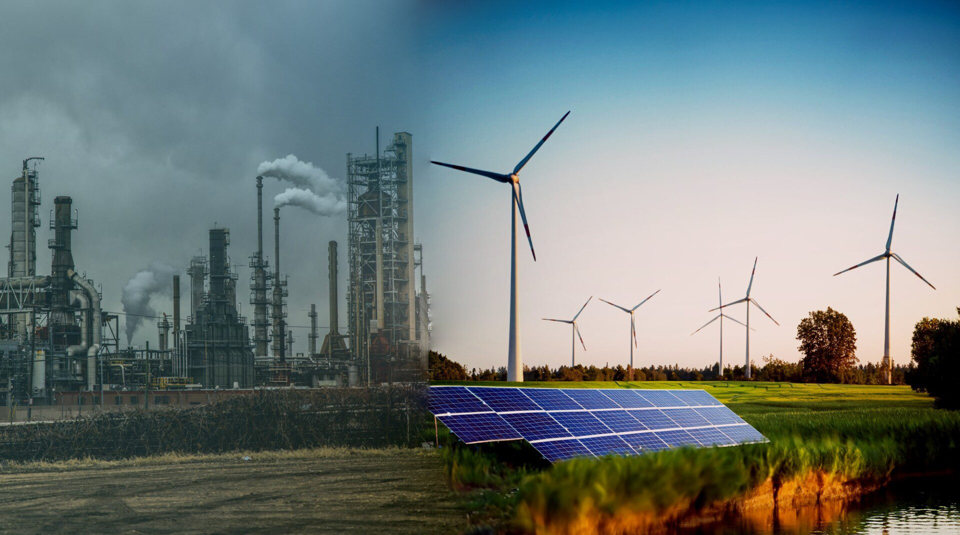

Article 1: The Green Transition and Modern Technology
The green transition is a global effort to reduce climate change and protect the environment. Today, many countries still depend on fossil fuels such as coal, oil, and gas. These energy sources produce large amounts of carbon dioxide (CO₂), which is one of the main causes of global warming.
To solve this problem, societies are changing the way they produce and use energy. This change is called the green transition. It includes using renewable energy sources such as wind power, solar energy, and hydropower. These energy sources are cleaner and do not run out in the same way as fossil fuels.
Technology plays an important role in this transition. Digital systems can help reduce energy use in many industries. For example, smart systems can control heating and electricity in buildings, and online services can reduce the need for travel.
However, technology is also part of the problem. The IT industry uses a lot of energy. Every time we stream videos, use cloud services, or store data online, we use electricity. As more people use digital services, the demand for energy increases.
Because of this, IT companies are working to become more sustainable. They are using renewable energy, improving their systems, and trying to reduce waste. This means that IT can be both part of the problem and part of the solution.

Article 2: Data Centers – The Heart of the Internet

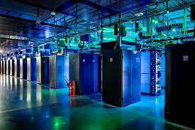

Data centers are very important in modern society. They are large buildings filled with servers that store and process data. Every time you use the internet, send a message, or watch a video, you are using a data center.
These facilities operate 24 hours a day, 7 days a week. The servers must always be running to provide fast and reliable services. Because of this, data centers use a lot of electricity.
One of the biggest challenges is heat. When servers work, they produce heat, and if the temperature gets too high, the systems can fail. To prevent this, data centers use cooling systems such as air conditioning or liquid cooling. These systems also use a lot of energy.
Some of the largest data centers in the world use as much electricity as entire cities. This makes them a significant contributor to global energy consumption.
To reduce their environmental impact, companies are developing new solutions. Many data centers now use renewable energy sources. Others are built in colder countries, where natural cooling can reduce energy use.
Another important solution is virtualization. Instead of using one physical server for one system, multiple systems can run on the same server. This reduces the number of machines needed and makes better use of resources.

Article 3: Sustainable IT and the Role of the Data Technician

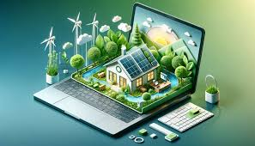

Sustainable IT is about using technology in a way that reduces environmental impact. This includes both hardware and software.
Energy-efficient hardware is designed to use less electricity. Newer servers, storage devices, and processors can perform better while using less power. Choosing the right hardware is an important step in reducing energy consumption.
Software also plays a major role. Programs that are not optimized can use more CPU power and require more resources. Efficient software design can reduce system load and save energy.
Another important issue is electronic waste, also known as e-waste. Many electronic devices are replaced after only a few years. These devices often contain harmful materials, and if they are not recycled properly, they can damage the environment.
As a future data technician, you will work with IT systems every day. You will install, maintain, and optimize systems. This gives you an important role in the green transition.
You can help by choosing energy-efficient solutions, reducing unnecessary data storage, and improving system performance. Small changes in IT systems can have a big impact when they are used on a large scale.

Part 1: Understanding
What is the green transition?
Why are fossil fuels a problem?
What is a data center?
Why do data centers use a lot of energy?

Part 2: Advanced Tasks
Explain the relationship between IT systems and energy consumption.
How does virtualization improve efficiency?
Explain cloud computing and its environmental impact.
What is e-waste and how should it be handled?

Part 3: Case Task
A company uses old servers, stores unnecessary data, and does not use green energy.
Identify three problems.
Suggest three improvements.
Explain how your solutions reduce energy consumption.

Part 4: Reflection
What responsibility do IT professionals have in the green transition?
How can you work sustainably as a data technician?

