Sustainability in Computing
What Happens to a Used Computer?
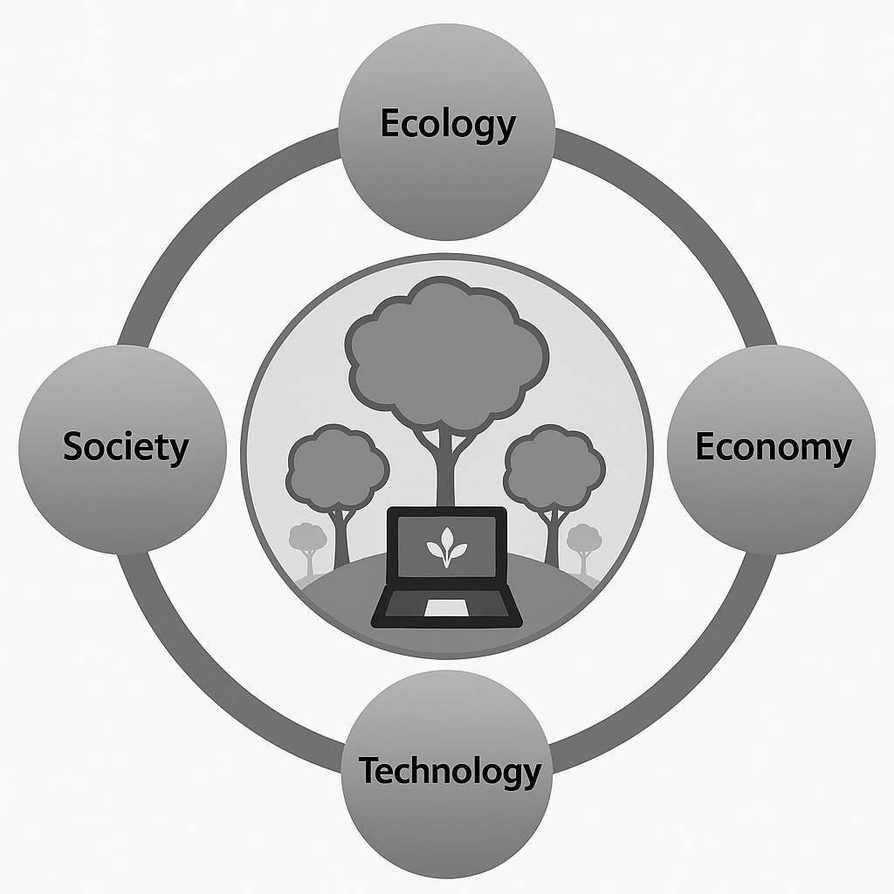

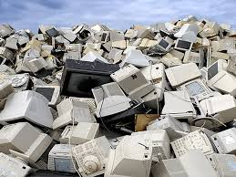
The tragic costs of e-waste - YouTube

Sustainability in Computing & What Happens to a Used Computer
The article discusses sustainability in computing and focuses on how computers affect the environment throughout their life cycle. Sustainability in computing means reducing the environmental impact caused by manufacturing, using, and disposing of computers. Producing computers requires large amounts of energy and raw materials such as metals, plastics, and rare earth elements. This process also creates carbon emissions and pollution.
Many people replace their computers every 3–5 years, often because of performance issues or the desire for newer technology. However, most computers are not completely broken when they are replaced. This leads to a growing problem known as electronic waste (e-waste). E-waste is one of the fastest-growing types of waste in the world, and it can be harmful because computers contain toxic substances like lead and mercury.
When a computer is no longer wanted, several things can happen to it. If it still works, it may be donated, sold, or refurbished. Refurbishing involves repairing or upgrading parts such as memory (RAM), storage drives, or batteries so the computer can continue to function effectively. Extending the lifespan of a computer reduces the demand for new devices, which helps save energy and natural resources.
If the computer cannot be reused, it may be recycled. During proper recycling, valuable materials like copper, aluminum, and even small amounts of gold can be recovered and reused in new products. However, if e-waste is not handled correctly, it may end up in landfills or be exported to countries where it is dismantled unsafely, causing environmental damage and health risks.
The article emphasizes that one of the most important solutions is improving “device literacy,” meaning people should learn how to maintain, repair, and upgrade their computers instead of immediately replacing them. By extending device lifespans, promoting reuse, and ensuring responsible recycling, individuals, schools, and companies can contribute to a more sustainable computing future.

Credits: From E-Waste to Eco-Wonder: Resurrecting Computers for a Sustainable Future | MDPI

The presentation:
You must create a PowerPoint presentation about sustainability in computing and include the following points: definition and introduction, environmental impact, what happens to a used computer, possible solutions, discussion questions, and a conclusion.

1. Introduction – What Is Sustainability in Computing?
- Define sustainability (meeting today’s needs without harming future generations).
- Explain sustainability in computing:
  - Reducing environmental impact of computers.
  - Thinking about production, use, and disposal.
- Why this topic is important today (technology is everywhere).

🌍 2. The Environmental Impact of Computers
Talk about the life cycle of a computer:
a) Production
- Requires metals, plastics, rare earth elements.
- Uses a lot of energy.
- Creates carbon emissions.
b) Usage
- Computers use electricity.
- Data centers consume large amounts of power.
c) Disposal
- Creates electronic waste (e-waste).
- E-waste is one of the fastest-growing waste streams in the world.

♻️ 3. What Happens to a Used Computer?
Explain the different possible outcomes:
- Reuse
  - Donated or sold.
  - Given to schools or charities.
- Refurbishing
  - Upgrading RAM, storage, battery.
  - Extends lifespan.
  - Reduces need for new production.
- Recycling
  - Materials like copper, aluminum, and gold are recovered.
  - Reduces need for mining.
- Landfill / Improper Disposal
  - Toxic materials can pollute soil and water.
  - Health risks.

🧠 4. Solutions – How Can We Make Computing More Sustainable?
- Keep devices longer.
- Repair instead of replace.
- Buy refurbished devices.
- Recycle responsibly.
- Learn basic device maintenance (“device literacy”).
- Companies designing products that are easier to repair.

💬 5. Discussion Questions (For Class Engagement)
You could ask your classmates:
- How often do you replace your phone or computer?
- Would you buy a refurbished computer? Why or why not?
- Should companies be required to make devices easier to repair?
- Who is responsible for e-waste — companies or consumers?

🎤 6. Conclusion
Summarize:
- Computers have environmental costs.
- Used computers don’t just “disappear.”
- Small changes (reuse, repair, recycle) can make a big difference.
- Sustainable computing is everyone’s responsibility.

