Green Transition in IT – Extended Assignment
Level: D-level (Data Technician)

Article 1: The Growing Digital World
The digital world is expanding rapidly. Every day, more devices are connected to the internet, and more data is created. This growth increases the demand for IT infrastructure such as servers, networks, and storage systems.
While digital solutions can improve efficiency, they also require energy. The more data we use, the more energy is needed to store, process, and transfer it. This creates environmental challenges that must be addressed.
IT professionals must understand how to balance performance with sustainability. Efficient system design is key to reducing energy consumption.
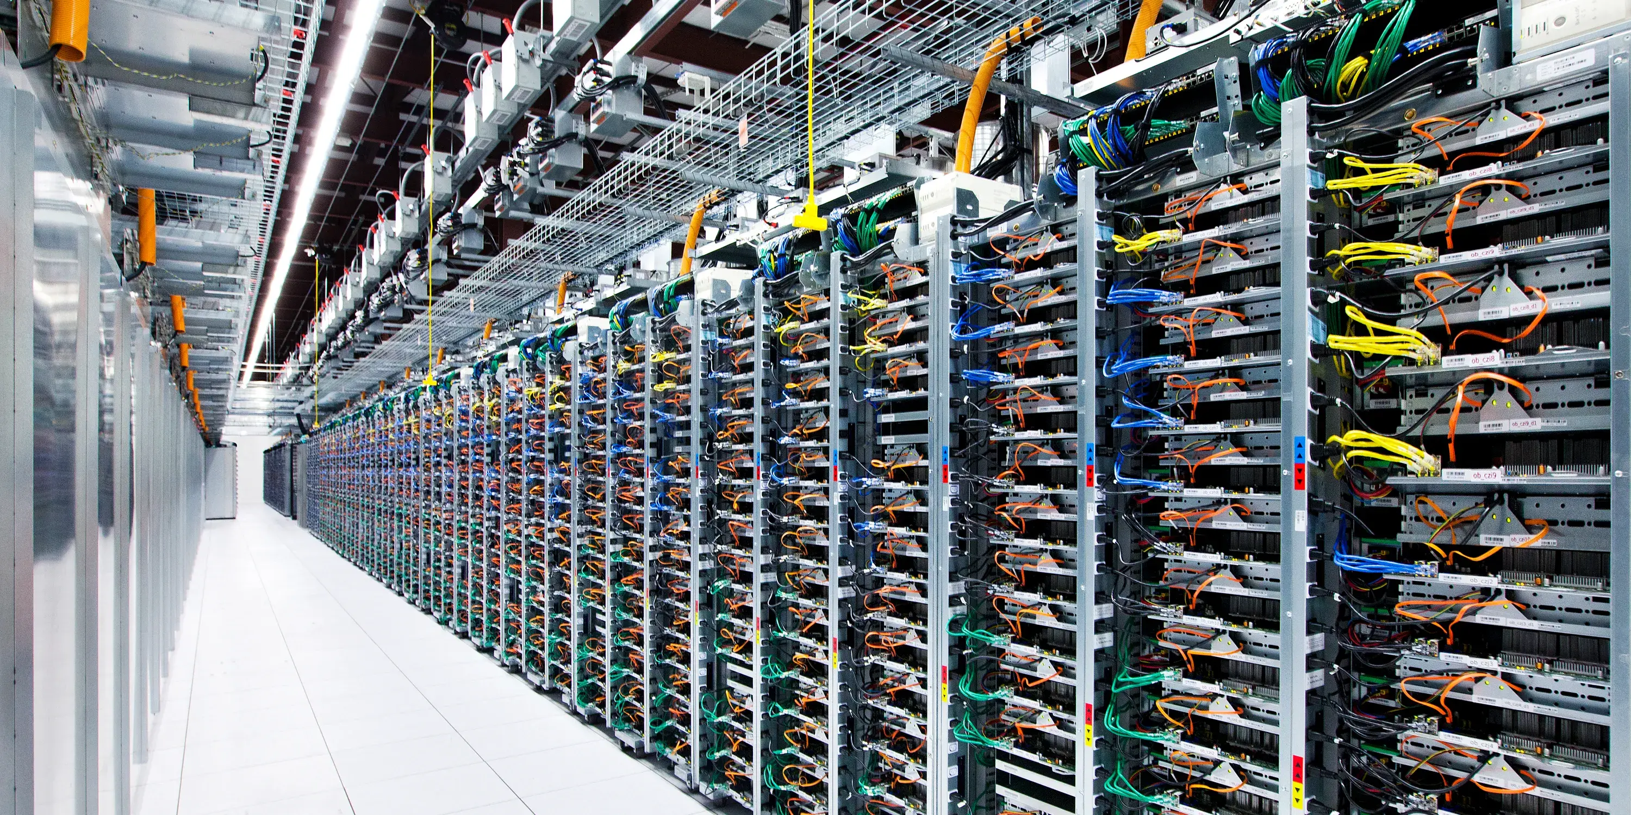

Article 2: Renewable Energy and IT Systems
Many IT companies are now using renewable energy to power their systems. Wind, solar, and hydroelectric power are becoming important alternatives to fossil fuels.
Using renewable energy can significantly reduce CO₂ emissions from IT infrastructure. However, it also requires planning and investment.
Combining renewable energy with efficient system design is essential for achieving sustainability goals.

Article 3: Software Efficiency and Green Coding

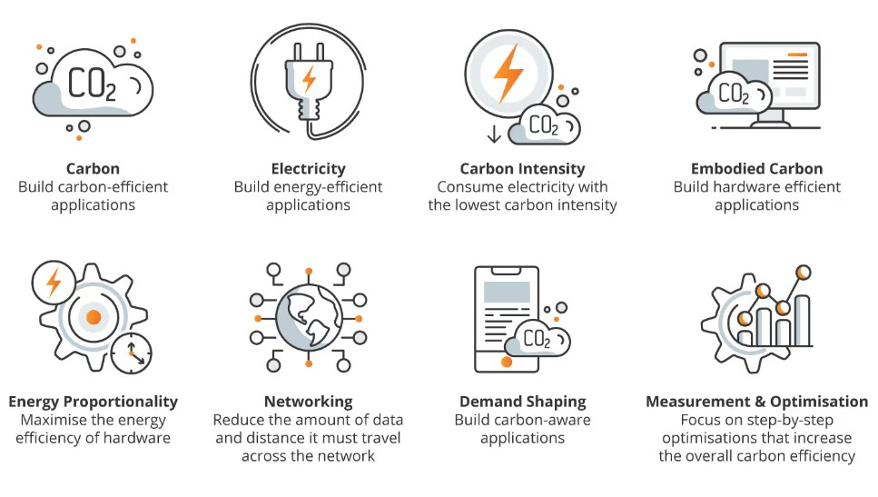

Software plays an important role in energy consumption. Inefficient code can increase CPU usage and require more hardware resources.
Green coding focuses on writing software that uses fewer resources. This includes optimizing algorithms, reducing unnecessary processes, and improving system performance.
By writing efficient code, developers can reduce energy use and contribute to the green transition.

Tasks
1. Summarize each article.
2. What are the main environmental challenges in IT?
3. How can renewable energy improve IT sustainability?
4. What is green coding?
5. How can you as a data technician support the green transition?

